**Class**

**What is a Class?**

A class in JavaScript is like a blueprint for creating objects with similar properties and behaviours. It helps in organizing and reusing code efficiently.

**How to Define a Class?**

You can define a class using the class keyword followed by the class name. Inside the class, you define properties and methods.

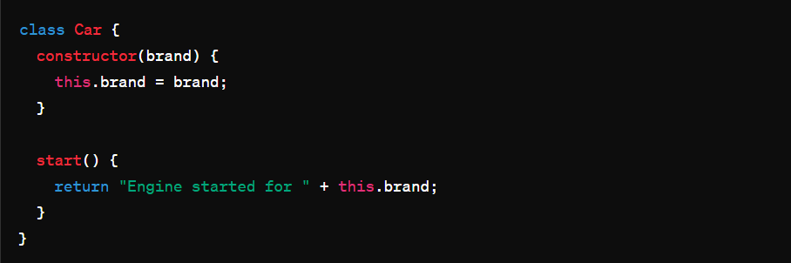

**Creating Objects from a Class:**

To create objects from a class, you use the **new** keyword followed by the class name and provide necessary parameters to the constructor.



**Intermediate Level:**

**Class Inheritance:**

Inheritance allows a class (subclass) to inherit properties and methods from another class (superclass). It helps in code reusability and structuring.

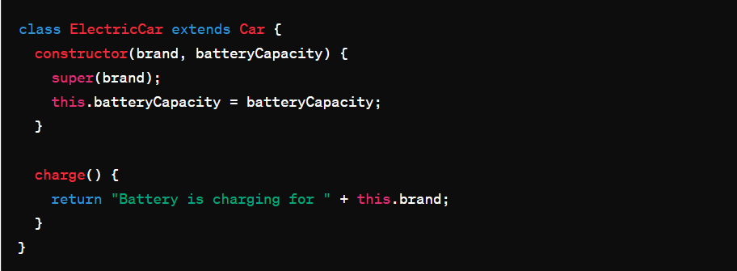

**Method Overriding:**

You can redefine a method in a subclass to customize its behavior while keeping the same method name.

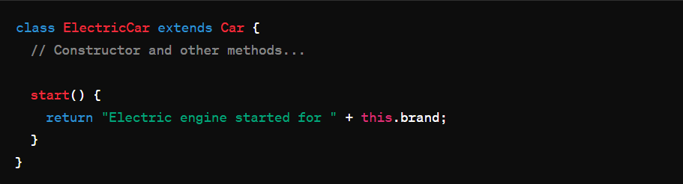

**Advanced Level:**

**Getters and Setters:**

Getters and setters are special methods that allow you to control access to the properties of an object.

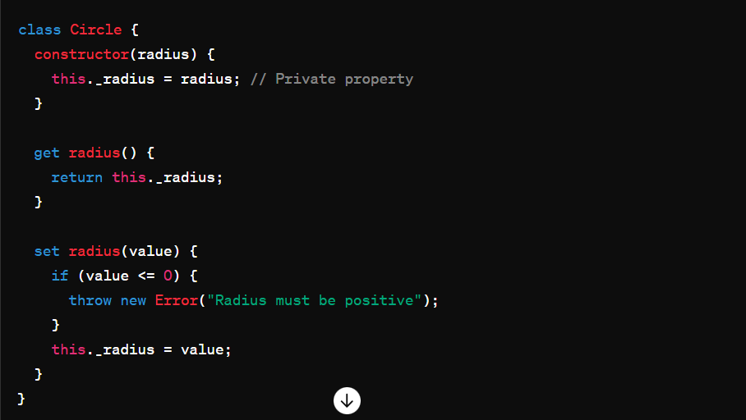

**Static Methods:**

Static methods belong to the class itself, not the instances of the class. They are called on the class rather than on an instance.

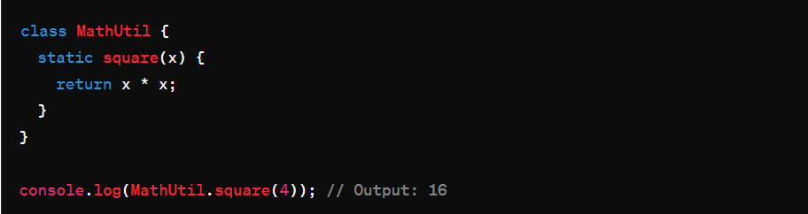

**Using Class Expressions:**

You can also define classes using expressions, similar to function expressions.

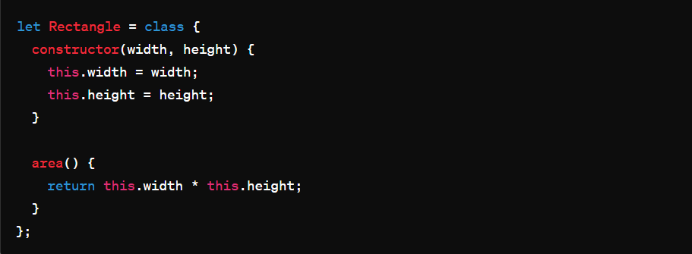

Classes in JavaScript provide a way to create objects with similar properties and behaviours. As you progress, you can explore more advanced concepts like inheritance, method overriding, getters/setters, static methods, and class expressions. Experimenting with these concepts through examples will help solidify your understanding.